***Type: xxx***

Melanoma Detection Using Deep Learning (DL).

# Fahim Uddin1, Nafisa Tafshir2, Mohammad Monirujjaman Khan1, *

1Department of Electrical and Computer Engineering,   
North South University, Bashundhara, Dhaka-1229, Bangladesh.  
*Corresponding Author: Mohammad Monirujjaman Khan. Email: monirujjaman.khan@northsouth.edu   
Received: XX Month 202X; Accepted: XX Month 202X

**Abstract:** Melanoma is a serious form of skin cancer that begins in cells known as melanocytes. Melanoma is more dangerous because of its ability to spread to other organs more rapidly if it is not treated at an early stage. Melanoma present in many different shapes, sizes and colors. That’s why it’s tricky to provide a comprehensive set of warning signs. Melanoma is usually curable when detected and treated early. Once melanoma has spread deeper into the skin or other parts of the body, it becomes more difficult to treat and can be deadly. While curable with early detection, only highly trained specialists are capable of accurately recognizing the disease. So, we propose a system that combines recent developments in deep learning with established machine learning approaches, creating ensembles of methods that are capable of segmenting skin lesions, as well as analyzing the detected area and surrounding tissue for melanoma detection. In this paper, we propose a method for classifying melanoma images into benign and malignant using Convolutional Neural Networks (CNNs).Classifying melanoma from dermoscopic images is now a current trend in AI based skin cancer detection methods but prerequisite is highly computation tools which take much time, effort and cost as well. In these cases, researchers train a huge number of images with 'Deep Learning' algorithms, basically with pretty deep neural architectures containing a huge number of parameters to train with, though they got their expected outcomes. In our research, we emphasized on building models with less complexity and comparatively better accuracy, so that melanoma can be identified with ease.

**Keywords:** Melanoma, Machine Learning, Deep Learning, CNN, ResNet50

1. **Introduction**

Skin cancer is a dangerous and widespread disease. Each year there are approximately 5.4 million new cases of skin cancer recorded in the USA alone. The global statistics are equally alarming. Recent reports show that the incidence of melanoma has risen considerably over the past 30 years, and more than 96,000 new cases are estimated to be diagnosed in the United States in 2019 {according to the recently published Cancer Facts & Figures 2019 report from the American Cancer Society}. The mortality rate of this disease is expected to rise in the next decade. The survival rate is less than 14% if diagnosed in later stages. However, if skin cancer is detected at early stages, the survival rate is nearly 97%. This demands the early detection of skin cancer. This project will address the issue of early diagnosis with improved accuracy.[1]

Skin cancer is very common in Europe, Australia and USA [14] and is almost always curable if recognized and treated early. The major risk factors related are skin color, sun exposure, climate, advanced age, genetic and familial history. The best way to detect melanoma is to recognize a new spot in the skin or a spot that is changing in size, shape and color. Early detection of skin cancer can avoid death [15]

If we look at the statistics from WHO, there are 324,635 new cases all around the globe, from which a total of 57,043 are death cases. It showed 18 people out of 100, can’t survive who had been diagnosed with Melanoma whether we stated it as curable. So, there is no doubt it’s alarming and a matter of concern to the dermatologists all across the globe.

1. **Method and Methodology**

We are using the concept of ResNet50 for classification. With ResNet50, instead of starting the learning process from scratch, the model starts from patterns that have been learned when solving a different problem. This way, the model leverages previous learnings and avoids starting from scratch. In image classification, ResNet50 is usually expressed through the use of pre-trained models. A pre-trained model is a model that was trained on a large benchmark dataset to solve a problem similar to the one that we want to solve.

Moreover, we are using a jupyter notebook/Google Colab to build the model

* 1. ***Dataset***

Every year International Symposium on Biomedical Imaging (ISBI) creates challenges in different aspects of biomedical fields. One of the challenges is Skin Cancer detection. The dataset we used for skin cancer detection was available on the ISIC [12] website, from the competition held in 2016. We took 5000 images of Benign and 5000 images of Malignant. To train our model we used 3500 images of each benign and malignant class and 1500 images for our testing.

This website contains different sizes of images, where we need to resize them. We resize our image to (224, 224, 3). So, our input image shape is (224, 224,3). Here is some glimpse of images we took for our tasks:

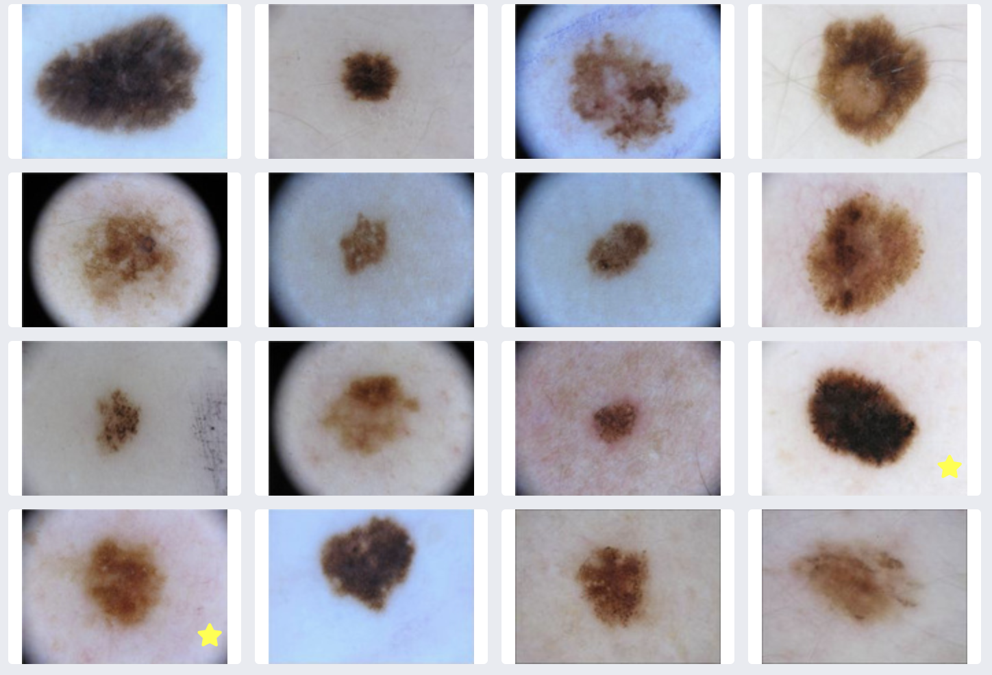

Figure : Random input images from ISIC dataset [16]

* 1. ***Convolutional Neural Networks (CNN)***

CNN’s are a kind of neural network that has proven to be very powerful in image recognition and classification. CNN’s can identify faces, pedestrians, traffic signs, and other objects better than humans and therefore are used in real-time applications like robots and self-driving cars. CNN’s are a supervised learning method and are trained using labeled data given with the respective classes. CNN’s learn the relationship between the input objects and the class labels and comprise two components: the hidden layers in which the features are extracted and, at the end of the processing, the fully connected layers used for the actual classification task. The hidden layers of CNN have a specific architecture consisting of convolutional layers, pooling layers, and activation functions for switching the neurons either on or off. In a typical neural network, each layer is formed by a set of neurons, and one neuron of a layer is connected to each neuron of the preceding layer while the architecture of hidden layers in CNN is slightly different. The neurons in a layer are not connected to all neurons of the preceding layer; instead, they are connected to only a small number of neurons from the previous layer. This restriction to local connections and additional pooling layers summarizing local neuron outputs into one value results in translation-invariant features. This results in a more straightforward training procedure due to fewer parameters and lower model complexity. The diagram as follows:

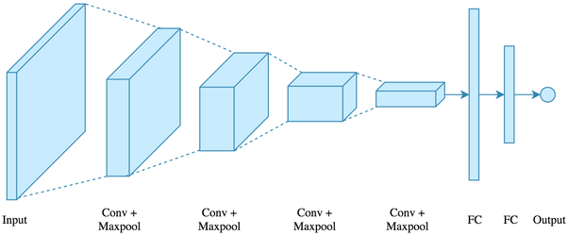

**Figure 2:** Layers of CNN [2]

* 1. ***ResNet50***

ResNet 50 architecture was re-trained on our dataset by fine-tuning across all layers and replacing top layers with one average pooling, one fully connected. Finally, the softmax layer allows the classification of 2 diagnostic categories. The input images’ size was all resized to (224, 224) to be compatible with this model. The learning rate was set to 0.0001 and Adam was used for the optimizer.[18] It uses identity mapping to map the inputs. This identity mapping does not have any parameters and is just there to add the output from the previous layer to the layer ahead. The identity mapping is multiplied by a linear projection to expand shortcuts’ channels to match the residual. The Skip Connections between layers add the outputs from previous layers to the outputs of stacked layers. This results in the ability to train much deeper networks than what was previously possible.

**System Flowchart**

The system will work as follows to predict melanoma.

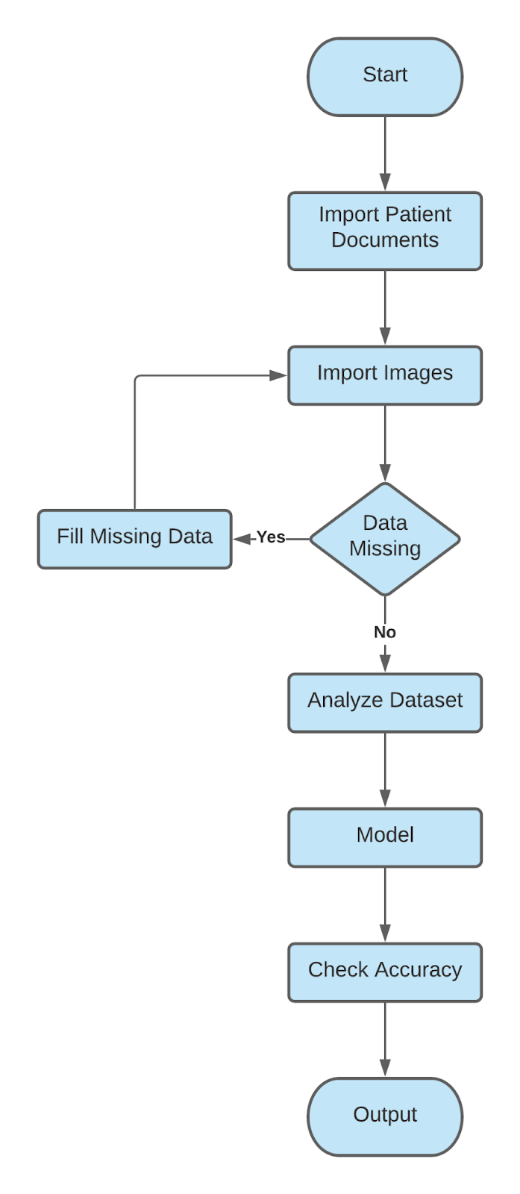

Figure : System Flowchart

According to the following flowchart the system will import patient data at first. Then the system will analyze the data & input the data in the Build Model. Then the model will check the accuracy.

**Proposed Model**

This is the proposed model of the whole system using ResNet50

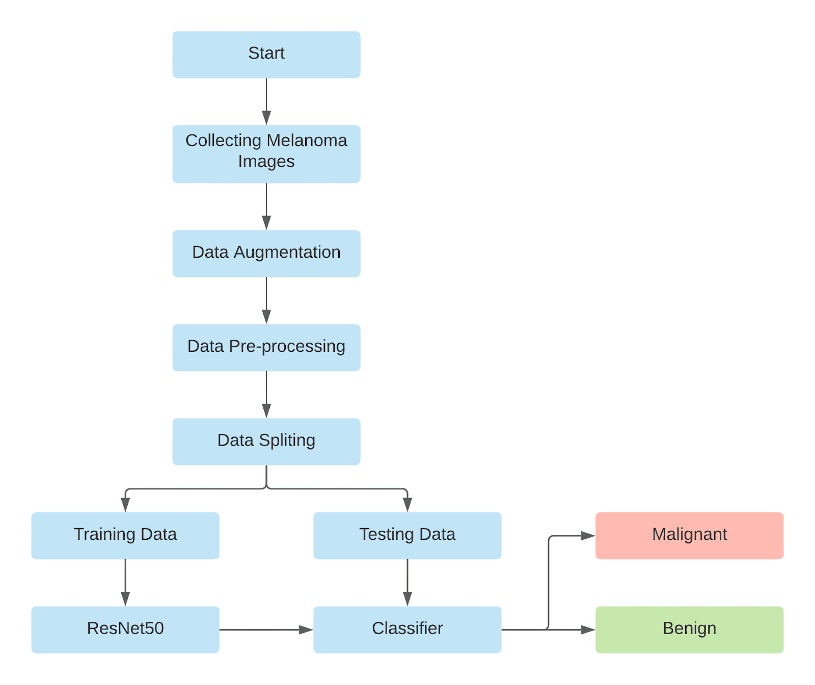

Figure : Proposed Model of using ResNet50

During the training of our model, we have to complete visualization of the dataset as the images of the dataset will be larger. Then we will split the data into train & test. The percentage of train & test will be as follows: Train - 70% & Test - 30%. There will be a classifier which will decide the output of the model.

**Proposed Solution**

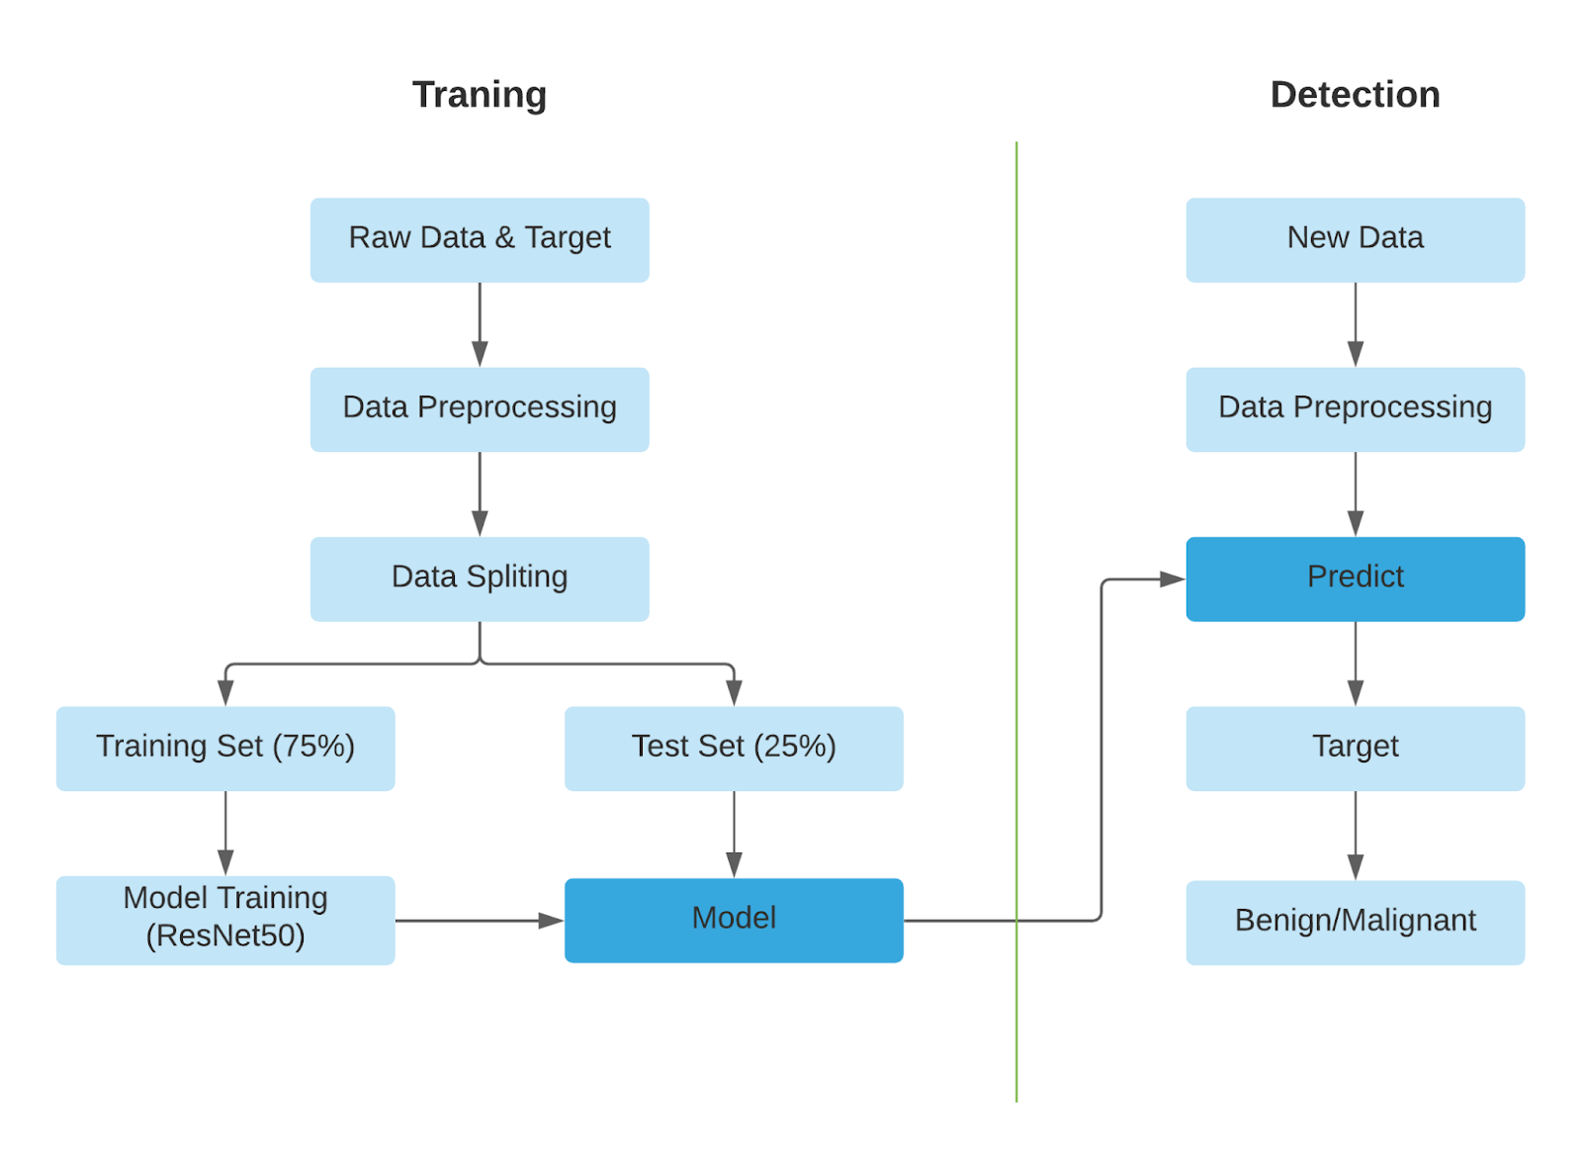

**Figure 5:** Proposed Solution

After preprocessing data, we will split the data into two portions. 70% will be used to train the model & 30% data will be used to test the model. After training the model the new data will be predicted in the trained model. Afterward the model gives the predicted result if the tumor is benign or malignant.

**Costing:** As the software & tools we are going to need in this project are available on the website. Moreover, the dataset for this project is also available on the web. Hence, we don’t need any financial support to complete this research-based project. But, in future when we will build & launch our software then we may need financial support.

1. **Results and Analysis**

So far in this semester we have successfully completed our Data Visualization, Model Building. The images of melanoma we collected from ISIC are very big in size. Due to the lack of a powerful GPU, we have shrunk our Dataset image size. We resized our dataset images 224 px * 224 px. Here is the result of our resized images.

To improve our accuracy, we have used a Keras Data Generator to randomly shuffle our images. We have used zoom, rotate, flip parameters to generate data. Then we build our ResNet50 Model.

In this section we present our findings. We plotted the loss vs epochs, accuracy vs epochs, confusion matrix for the classifier and ROC-AUC curve for the classifier. The plots are shown in Fig 10

**Figure**

We evaluated the performance of the proposed model based on different metrics: accuracy, recall, sensitivity, specificity, and precision. &e metrics are evaluated by various parameters in the confusion matrix, such as true positive (TP), true negative (TN), false positive (FP), and false negative (FN).

The details of experiment demonstrating the effect of training dataset size is shown in Table 1

|  |  |  |  |
| --- | --- | --- | --- |
| **Train Size** | **Precision** | **Recall** | **F1 Score** |
|  |  |  |  |
|  |  |  |  |

Table 1: Effect of batch size on result

Next, we present our findings and show the validation of our trained models. In this paper, two types of major skin cancer categories are used. The evaluation and results of trained models is calculated by common classification metrics. The ROC curve is calculated by plotting the sensitivity against 1 specificity and can be used to evaluate the classifier. The further the ROC curve deviates from the diagonal, the better the classifier. We found that a batch size value of 64 gives better results when compared to that of 32 as shown in Table 2.

|  |  |  |  |  |  |
| --- | --- | --- | --- | --- | --- |
| **Batch Size** | **Accuracy** | **Precision** | **Recall** | **F1 Score** | **ROC-AUC** |
|  |  |  |  |  |  |
|  |  |  |  |  |  |
|  |  |  |  |  |  |

Table 2: Effect of learning rate on result

The comparison with previous state of the art results is shown in Table 3.

|  |  |  |  |
| --- | --- | --- | --- |
| **Year** | **Author** | **Purpose** | **Accuracy** |
| 2016 [7] | 1. V. Pomponiu | Deep neural networks for skin mole lesion classification. | 93.64 |
| 2017 [8] | 1. N. C. Codella | Deep learning ensembles for melanoma recognition in dermoscopy images | 93.1 |
| 2018 [9] | 1. H. A. Haenssle | diagnostic performance of a deep learning convolutional neural network for dermoscopic melanoma recognition in comparison to 58 dermatologists. | -------- |
| 2017 [6] | 1. L. Bi | Automatic skin lesion analysis using large-scale dermoscopy images and deep residual networks | -------- |
| 2018 [17] | 1. S. S. Han | Classification of the clinical images for benign and malignant cutaneous tumors using a deep learning algorithm | -------- |
| 2016 [5] | 1. J. Kawahara and G. Hamarneh | Multi-resolution-tract cnn with hybrid pretrained and skin-lesion trained layers. | 79.5 |
| 2017 [4] | 1. A. R. Lopez | Skin lesion classification from dermoscopic images using deep learning techniques | 81.33 |
| 2016 [10] | 1. ENasr-Esfahani | Melanoma detection by analysis of clinical images using convolutional neural networks | 81 |

Table 3: Comparison with previous work

1. **Conclusion**

This Melanoma cancer is cancer that is difficult to detect in an ordinary way. Besides being a person with melanoma cancer does not feel pain, the form of melanoma cancer is also similar to ordinary moles. In the case of melanoma cancer the damage to DNA is caused by overexposure to ultraviolet rays (UV), and the affected cells are the melanocytes that produce melanin (pigmentation of the skin).In conclusion, this study will investigate the ability of deep convolutional neural networks in the classification of benign vs malignant skin cancer We Will try to show that with use of very deep convolutional neural networks using transfer learning and fine-tuning them on dermoscopy images, better diagnostic accuracy can be achieved compared to expert physicians and clinicians if a cost effective system can be built, it can easily be reachable to general people and melanoma screening can be more easier. And yes, saving lives is our ultimate goal. To build a cost-effective model, we presented the knowledge distillation method. A way of transferring knowledge from one network to another, with experimental results over several images of Melanoma datasets the main goal was to save lives from diseases like Melanoma with the help of new technology.

**Acknowledgment:** Authors would like to thank the Department of Electrical and Computer Engineering of North South University

**Conflicts of Interest:** “The authors declare that they have no conflicts of interest to report regarding the present study.”

**References**

1. <https://www.sciencedirect.com/science/article/pii/S2352914819302047>
2. <https://www.quora.com/What-is-a-convolutional-neural-network>
3. <https://sci-hub.se/https://ieeexplore.ieee.org/abstract/document/9034624>
4. A. R. Lopez, X. Giro-i Nieto, J. Burdick, and O. Marques. Skin lesion classification from dermoscopic images using deep learning techniques. In 2017 13th IASTED international conference on biomedical engineering (BioMed), pages 49–54. IEEE, 2017.
5. J. Kawahara and G. Hamarneh. Multi-resolution-tract cnn with hybrid pretrained and skin-lesion trained layers. International workshop on machine learning in medical imaging, pages 164–171.Springer, 2016.
6. L. Bi, J. Kim, E. Ahn, and D. Feng. Automatic skin lesion analysis using large-scale dermoscopy images and deep residual networks. arXiv preprint arXiv:1703.04197, 2017.
7. V. Pomponiu, H. Nejati, and N.-M. Cheung. Deepmole: Deep neural networks for skin mole lesion classification. In 2016 IEEE International Conference on Image Processing (ICIP), pages 2623–2627. IEEE, 2016.
8. N. C. Codella, Q.-B. Nguyen, S. Pankanti, D. A. Gutman, B. Helba, A. C. Halpern, and J. R. Smith. Deep learning ensembles for melanoma recognition in dermoscopy images. IBM Journal of Research and Development, 61(4/5):5–1, 2017.
9. H. A. Haenssle, C. Fink, R. Schneiderbauer, F. Toberer, T. Buhl, A. Blum, A. Kalloo, A. B. H.Hassen, L. Thomas, A. Enk, et al. Man against machine: diagnostic performance of a deep learning convolutional neural network for dermoscopic melanoma recognition in comparison to 58 dermatologists. Annals of Oncology, 29(8):1836–1842, 2018.
10. E. Nasr-Esfahani, S. Samavi, N. Karimi, S. M. R. Soroushmehr, M. H. Jafari, K. Ward, and K. Najarian. Melanoma detection by analysis of clinical images using convolutional neural networks. In 2016 38th Annual International Conference of the IEEE Engineering in Medicine and Biology Society (EMBC), pages 1373–1376. IEEE, 2016.
11. <https://www.researchgate.net/publication/340880583_Analyzing_Lung_Disease_Using_Highly_Effective_Deep_Learning_Techniques>
12. ISIC Challenge. Available: https://challenge.isic-archive.com/.
13. S. Ogden and N. R. Telfer, “Skin cancer,” Medicine (Baltimore) 37(6), 305–308 (2009).
14. S. Ogden and N. R. Telfer, “Skin cancer,” Medicine (Baltimore) 37(6), 305–308 (2009).
15. A. O. Berg, D. Best; US Preventive Services Task Force, “Screening for Skin Cancer: recommendations and rationale,” Am. J. Prev. Med. 20(3 Suppl), 44–46 (2001).
16. <https://tinyurl.com/isicmelanomadataset>
17. S. S. Han, M. S. Kim, W. Lim, G. H. Park, I. Park, and S. E. Chang. Classification of the clinical images for benign and malignant cutaneous tumors using a deep learning algorithm. Journal of Investigative Dermatology, 138(7):1529–1538, 2018.